|  |
| --- |
|  |
| C# Project Report  [Document subtitle] |
| |  |  |  | | --- | --- | --- | | Group Name |  | [Course title] | |

1.Login

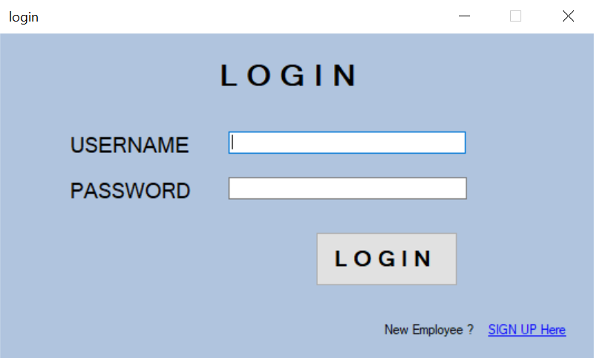

Explanation

2. Home

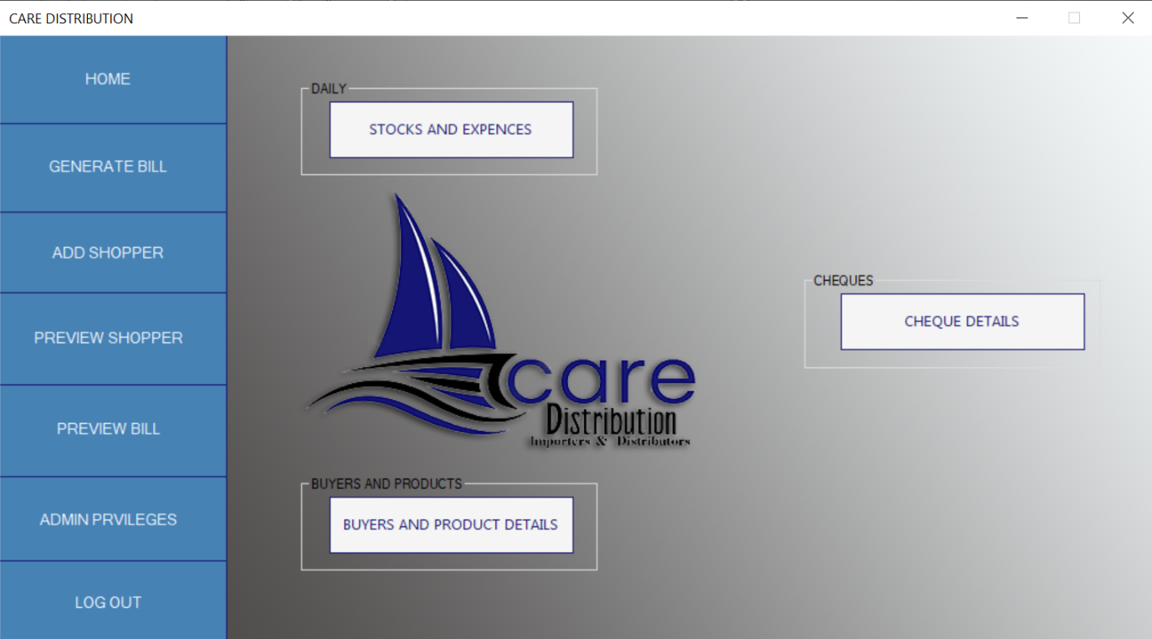

Explanation

3.Generate Bill

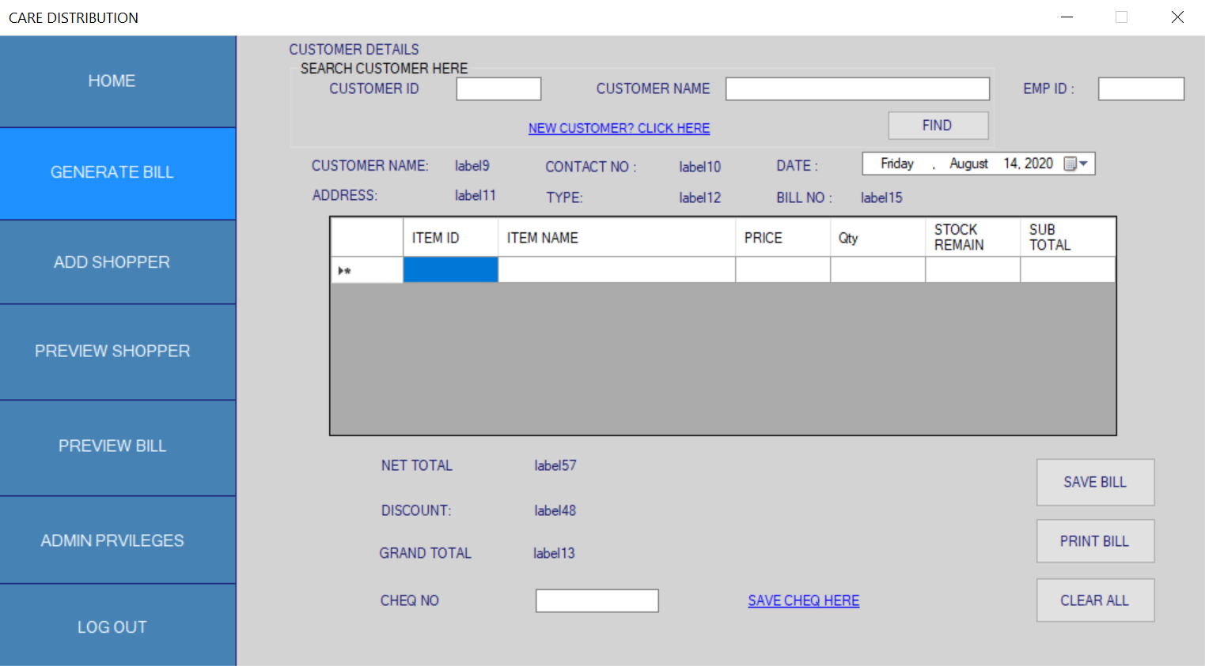

Explanation

4.Add Shopper

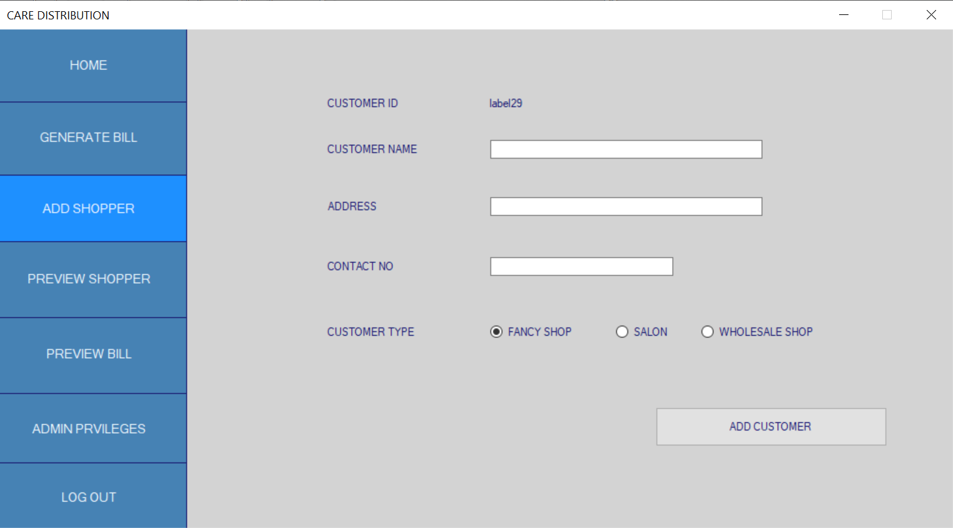

Explanation

5.Preview Shopper

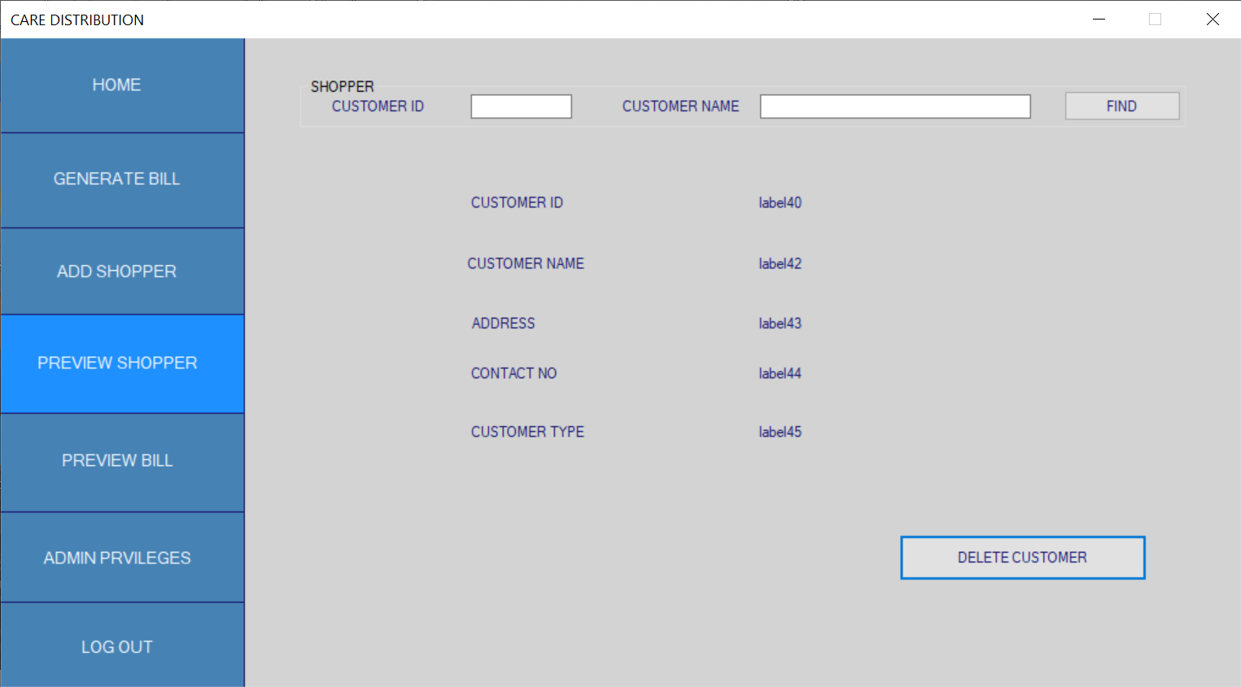

Explanation

6.Preview Bill

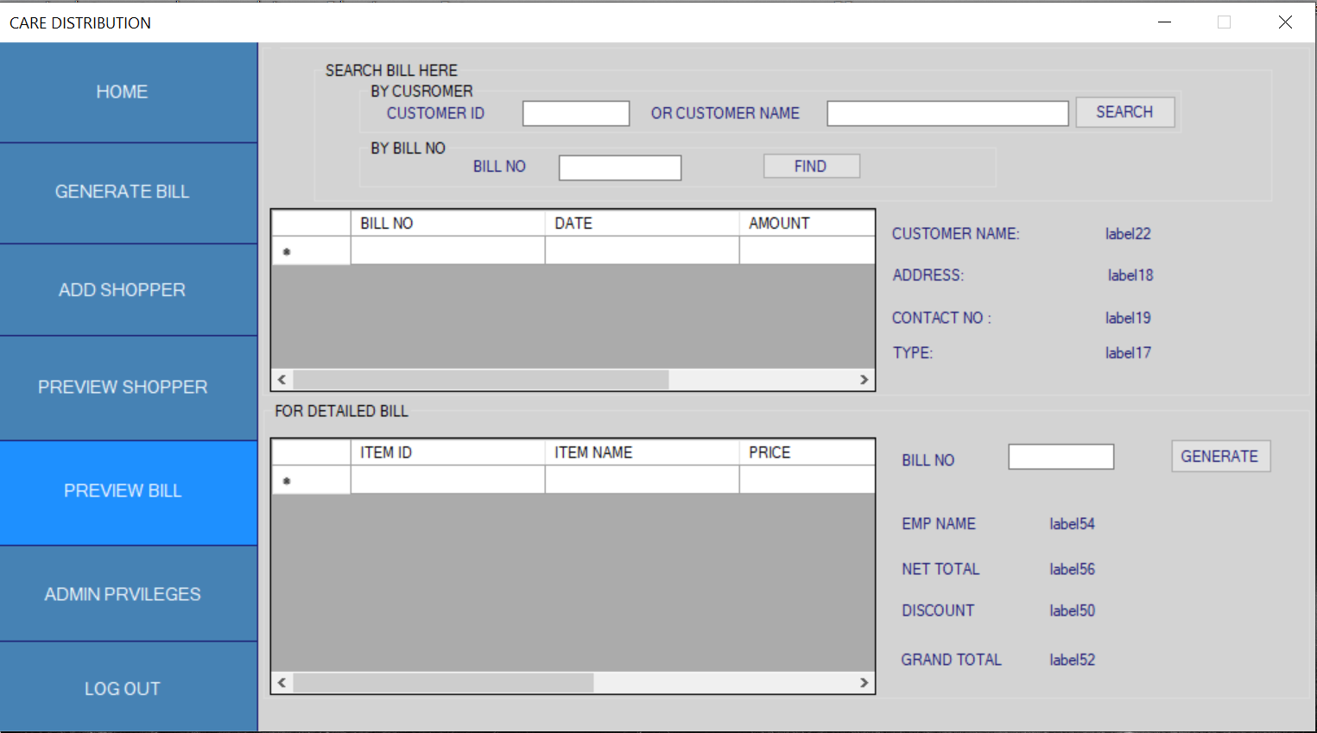

Explanation

7.Admin Privileges

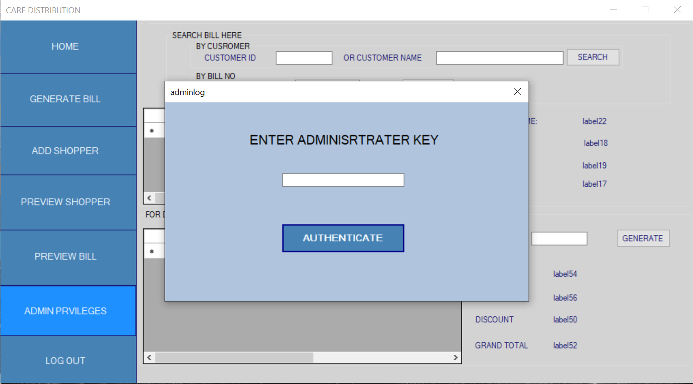

Explanation

8.Sales Profit Calculator

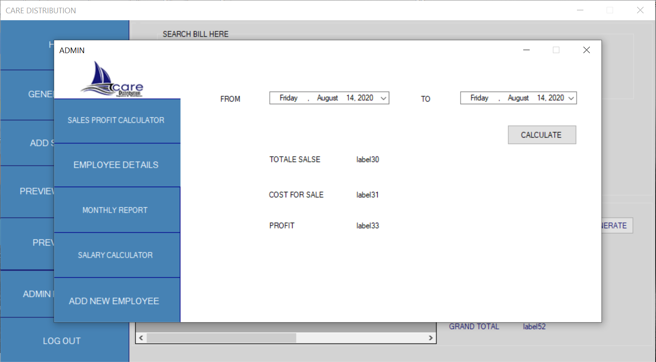

Explanation

9.Employee Details

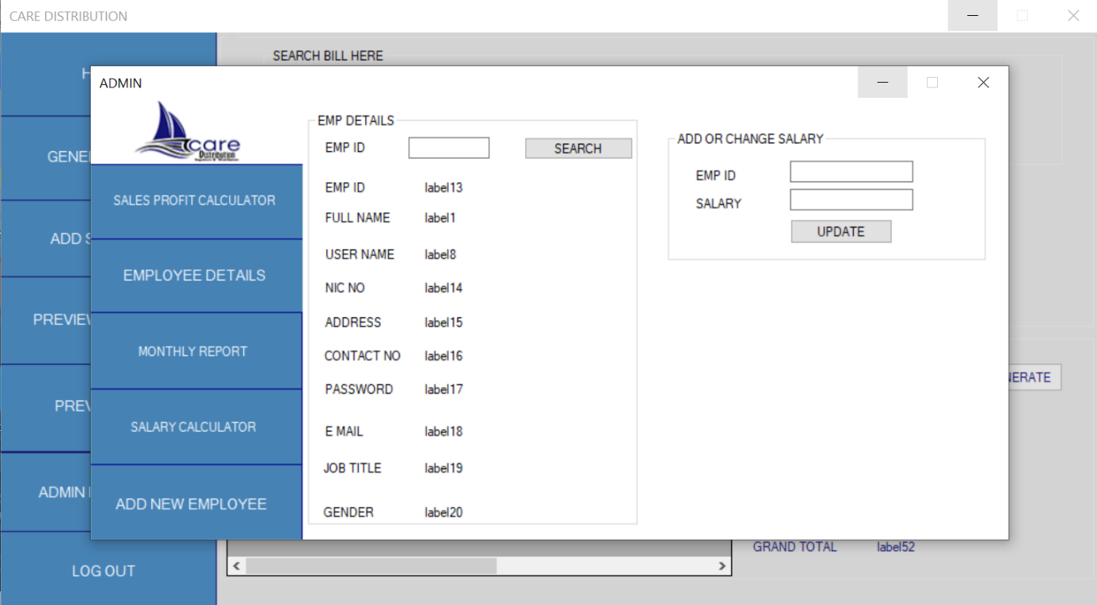

Explanation

10.Monthly Report

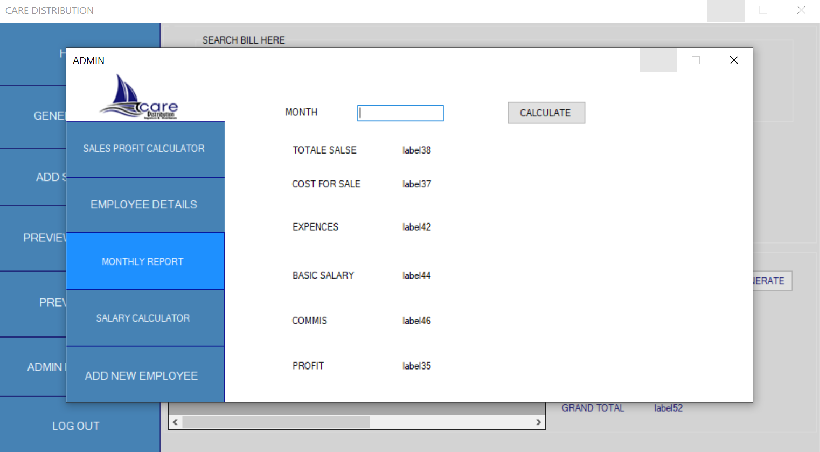

Explanation

11.Salary Calculator

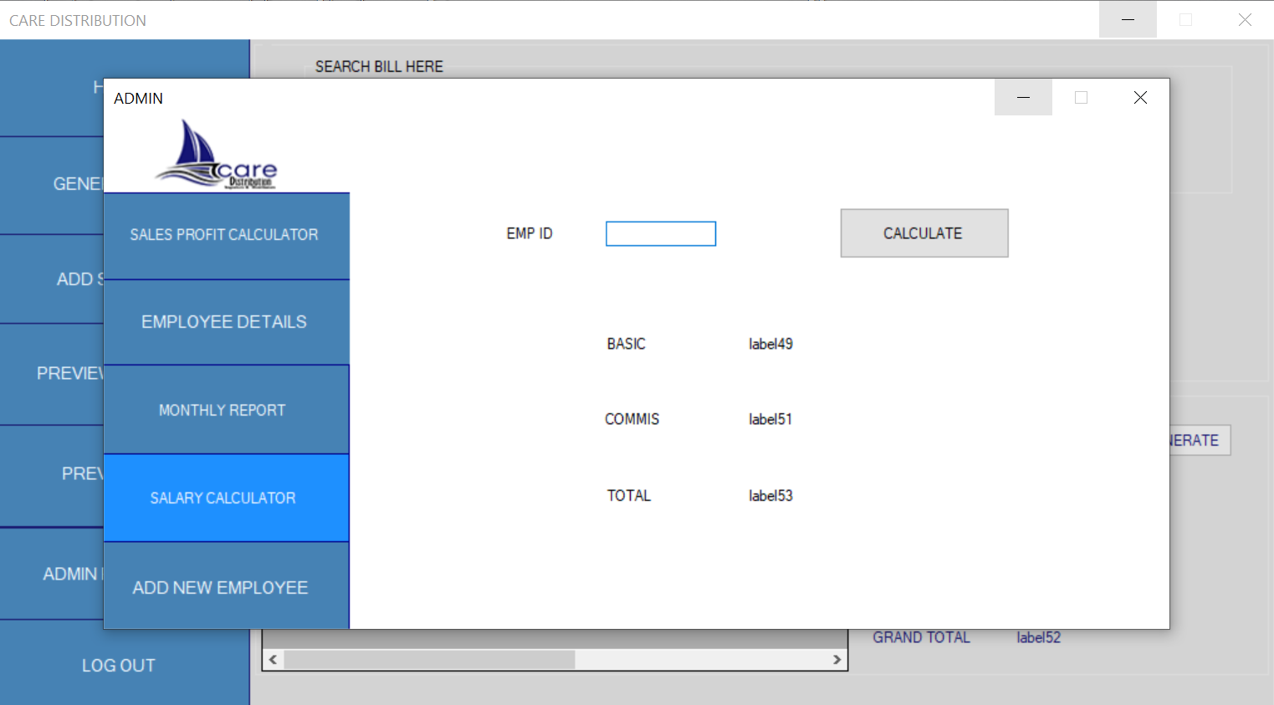

Explanation

12.Add New Employee

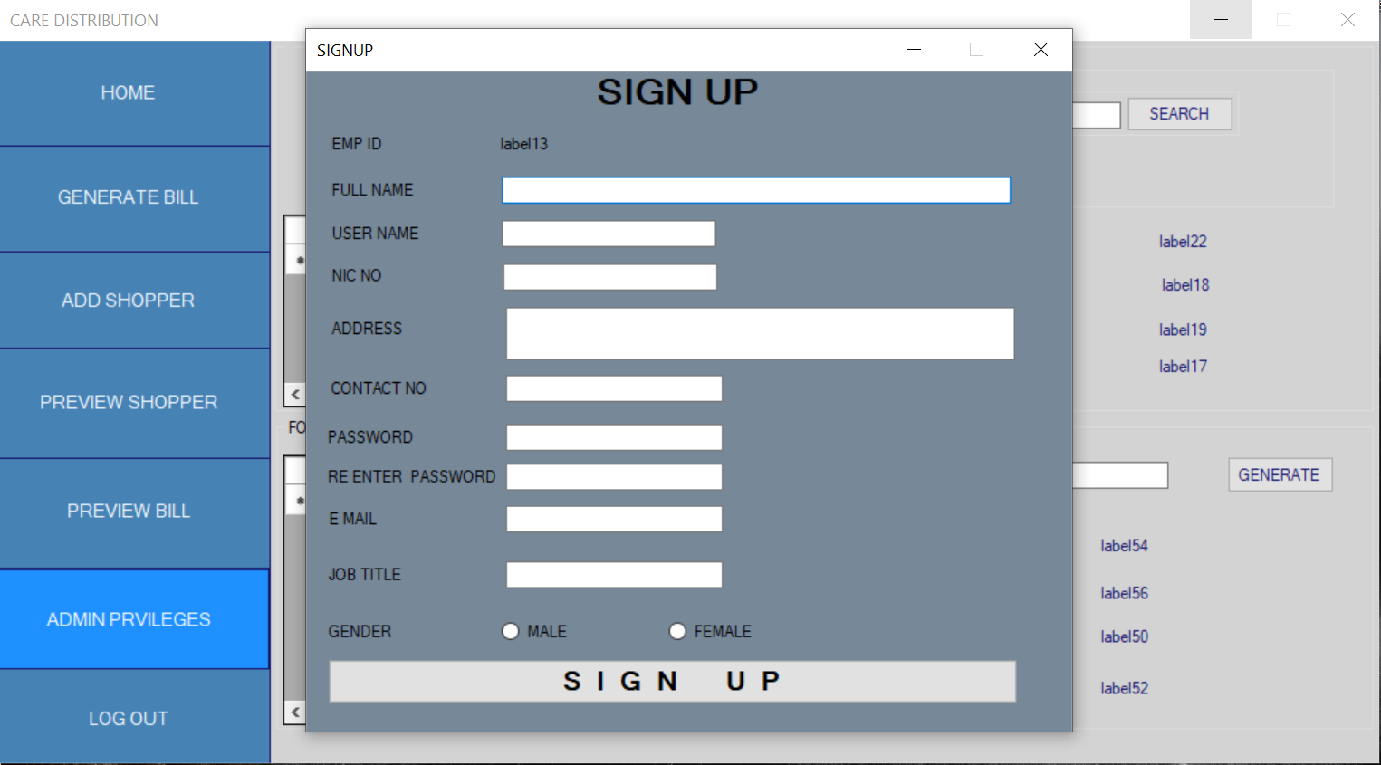

Explanation

13.Stocks & Expenses

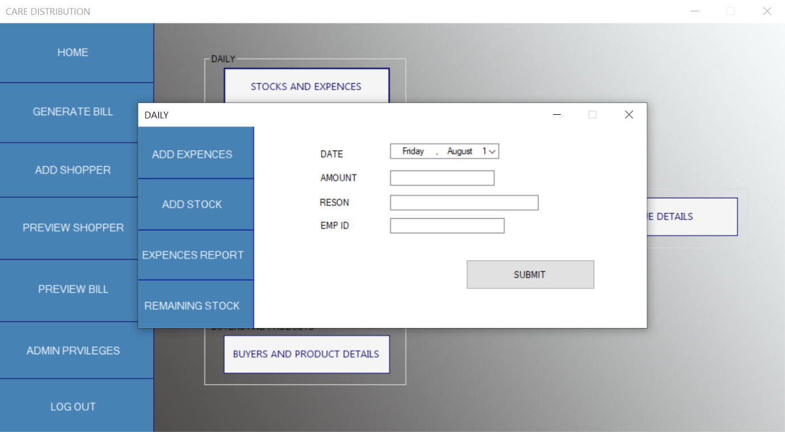

Explanation

14.Add Expanses



Explanation

15.Add Stock

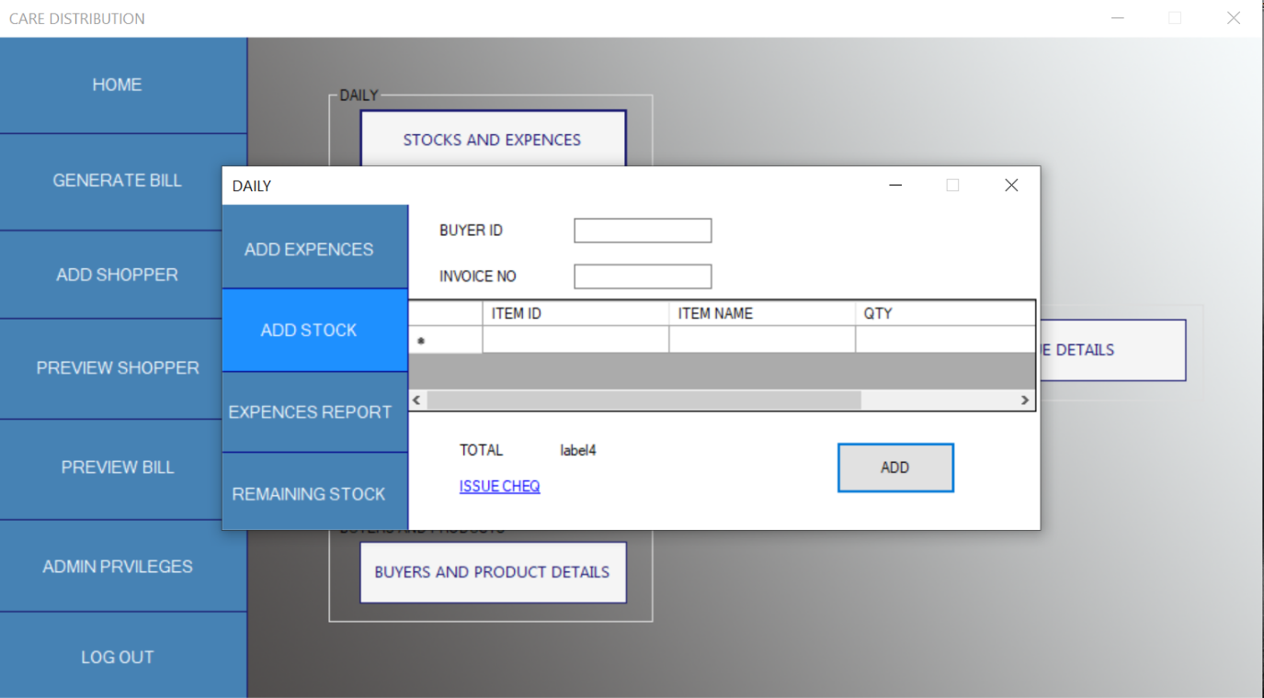

Explanation

16.Expenses Report

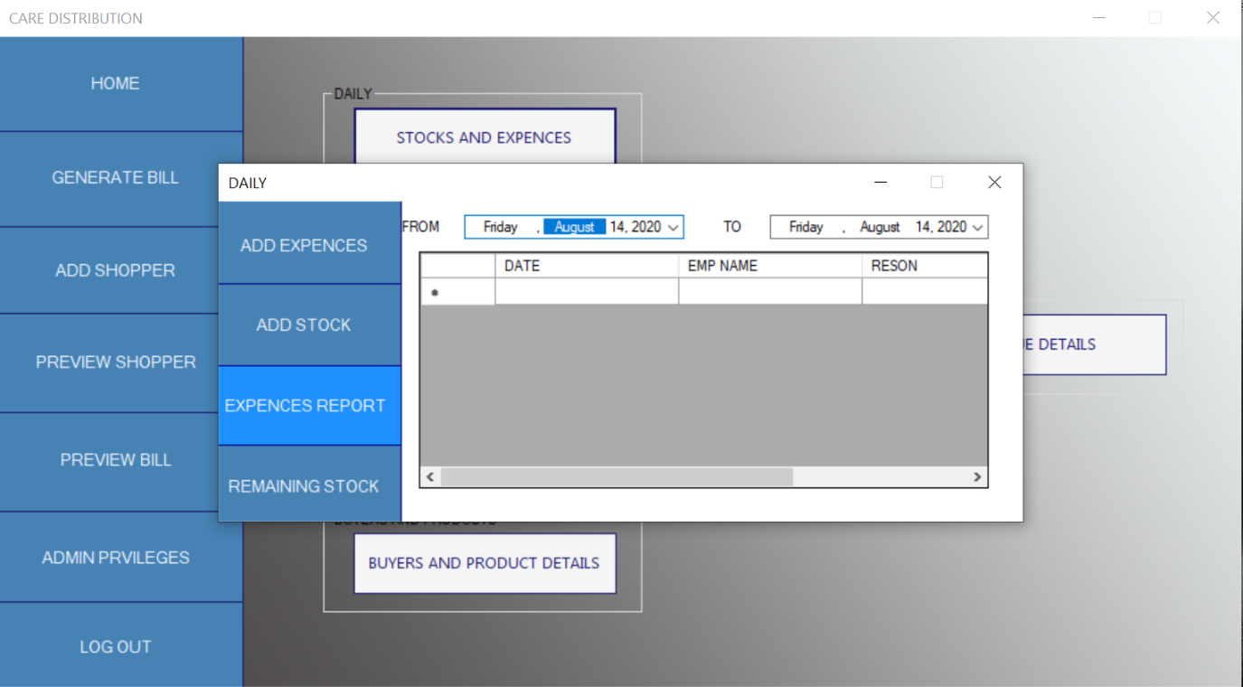

Explanation

17.Remaining Stock

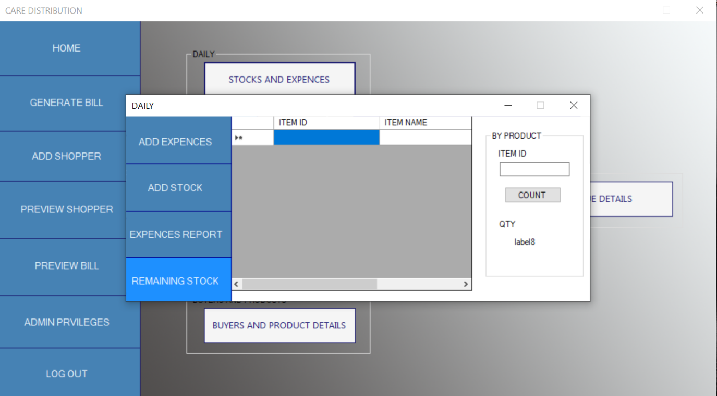

Explanation

18.Cheque Details

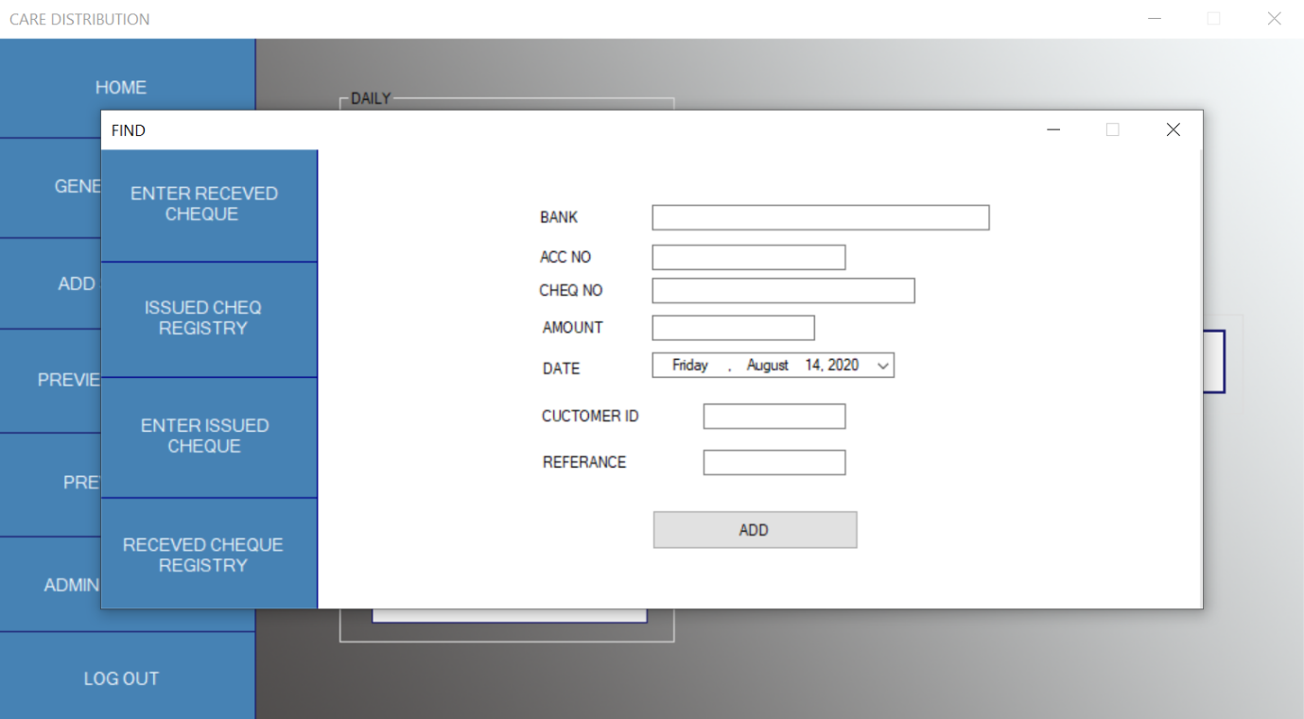

Explanation

19.Enter Received Cheque



Explanation

20.Issued Cheque Registry

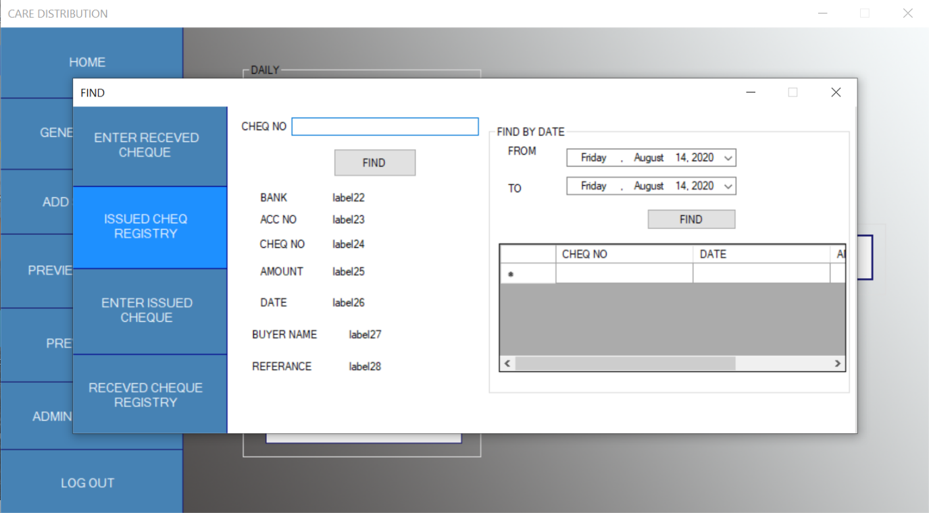

Explanation

21.Enter Issued Cheque

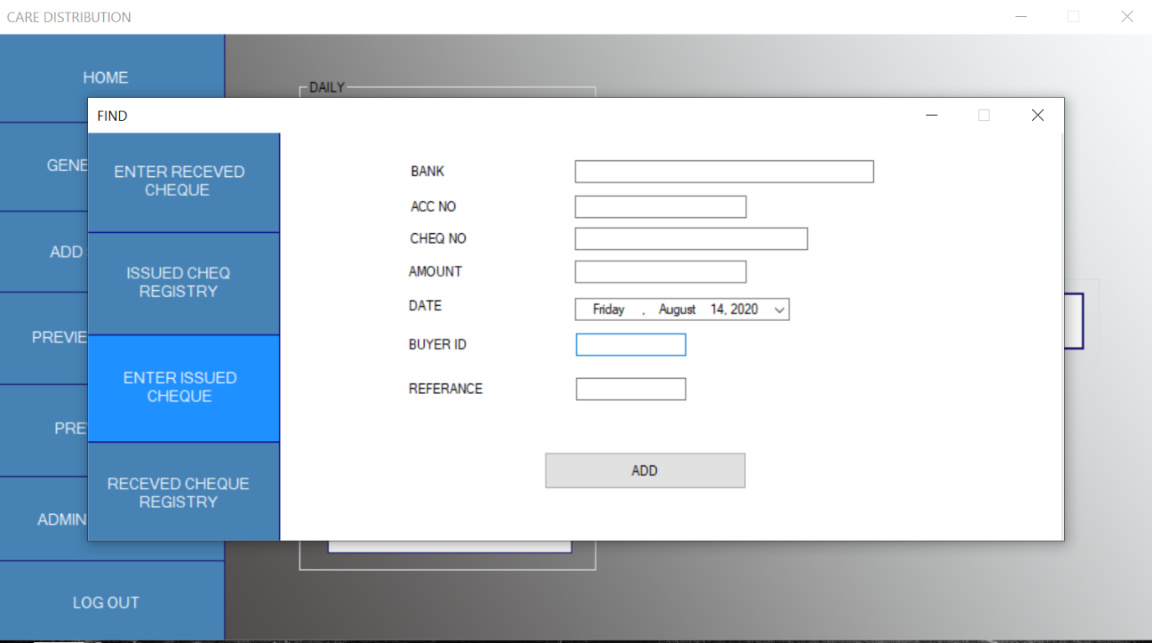

Explanation

22.Received Cheque Registry

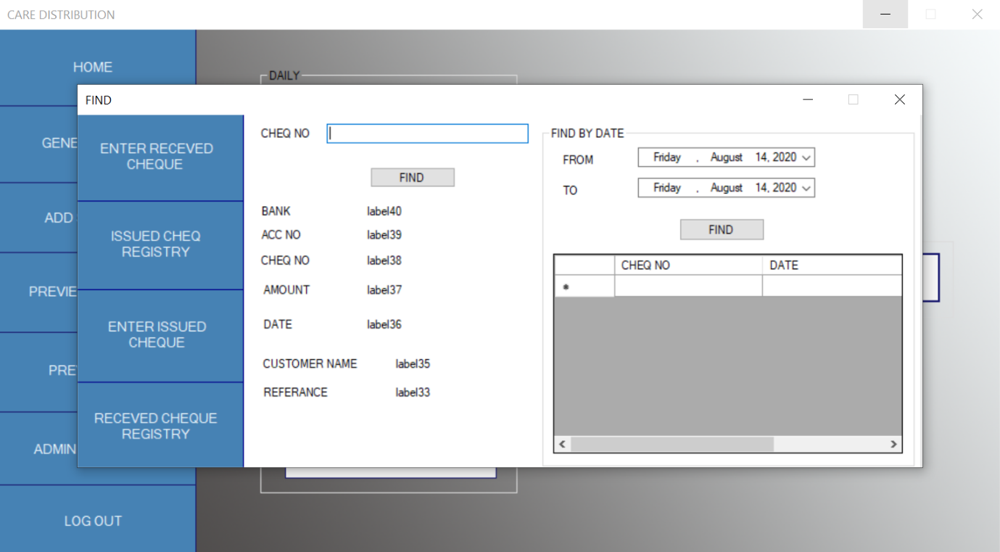

Explanation

23.Buyers & Product Details

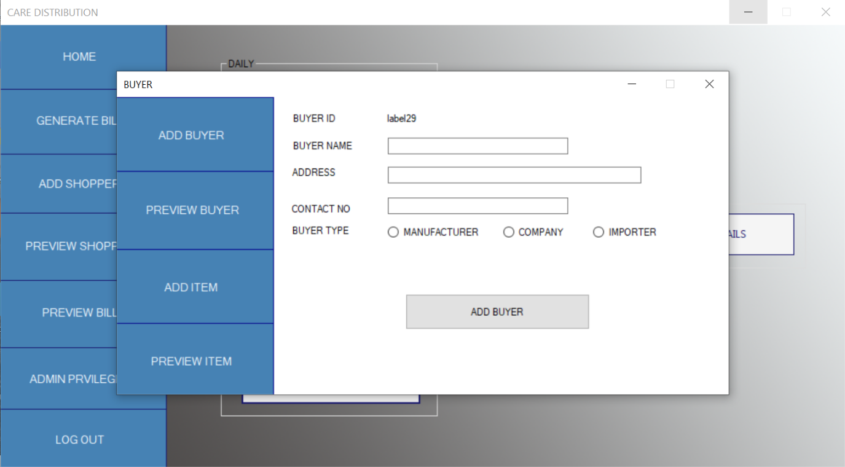

Explanation

24.Preview Buyer

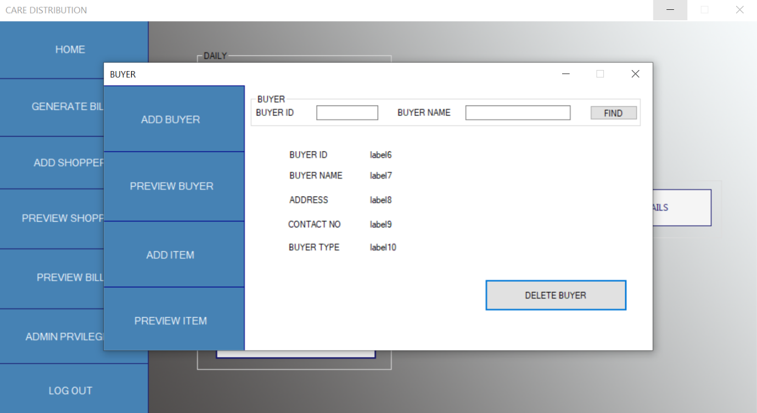

Explanation

25.Add Item

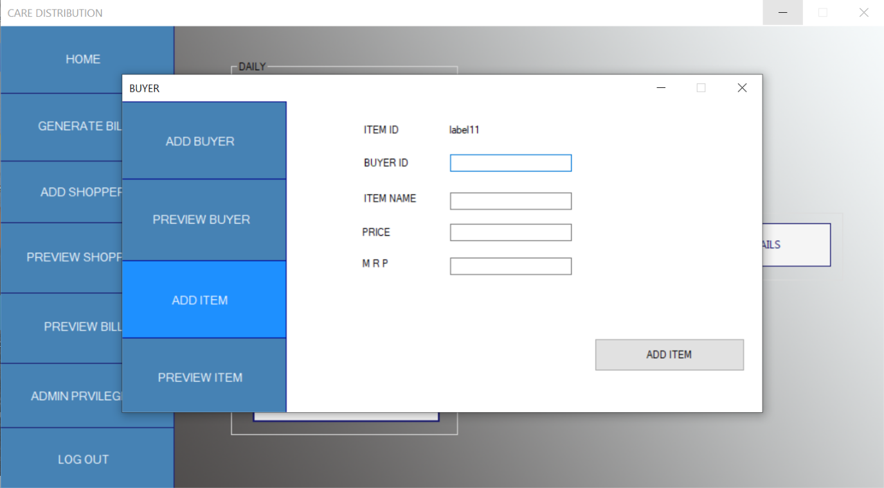

Explanation

26.Preview Item

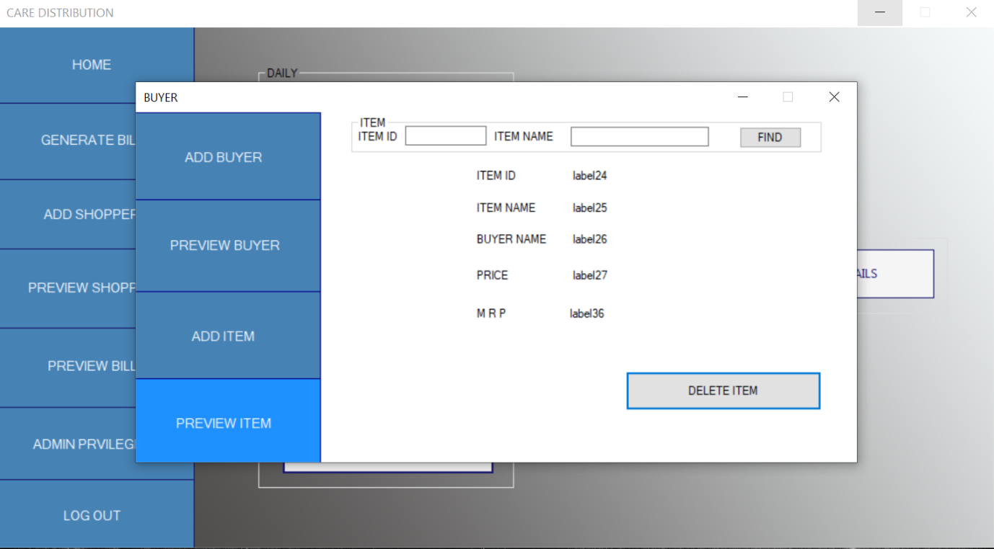

Explanation

27.Log Out

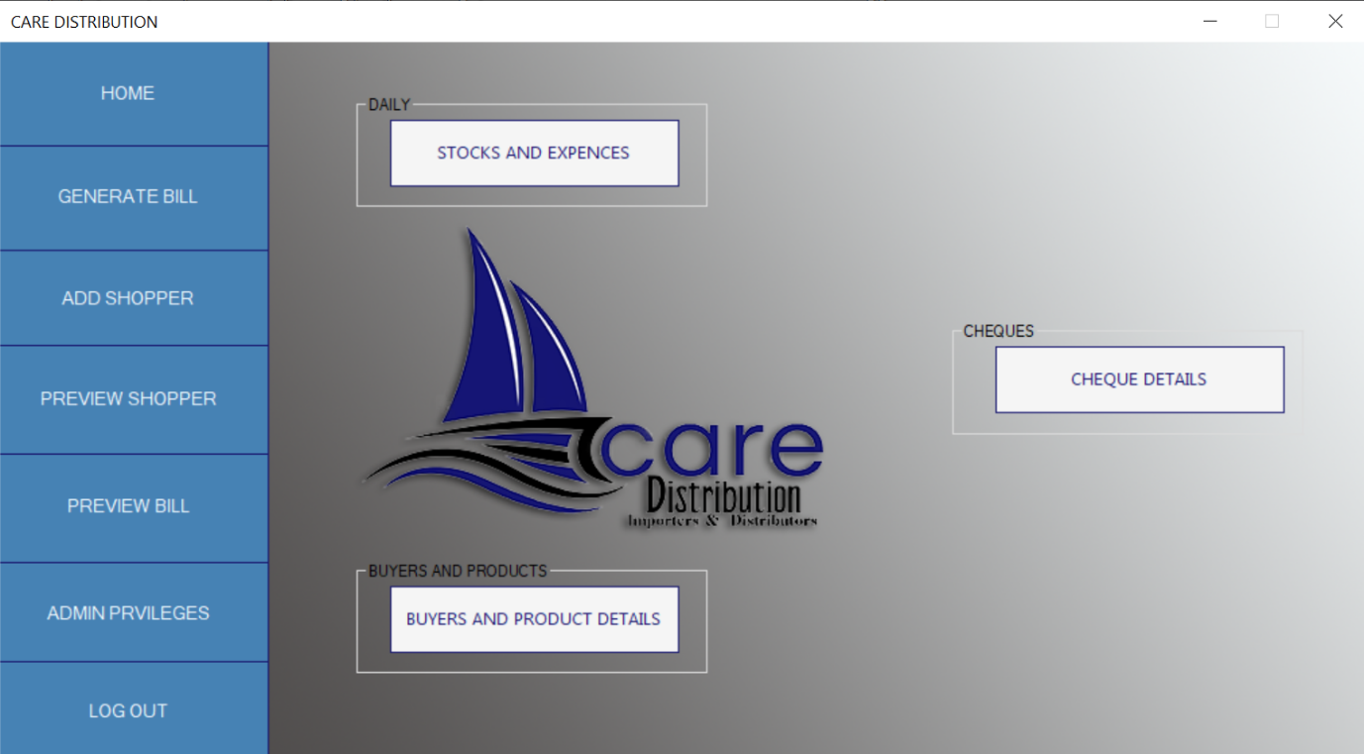

Explanation